**GLOBAL SCHOOL OF SCIENCE**



**PROJECT WORK**

**(COMPUTER SCIENCE)**

|  |  |  |
| --- | --- | --- |
| **SUBMITTED BY:** |  | **SUBMITTED TO:** |
| **Krishna Khanal**  **Class: XI ‘R1’**  **Roll No.:12** |  | **Milan Baral**  **Department of Computer Science** |

**KATHMANDU, NEPAL**

**2025**

**A Project On**

**Ms-Word/ Ms-Excel/ Ms-PowerPoint/ HTML/ CSS and C Programming**

Submitted as a partial fulfilment of requirement of the curriculum of **GRADE-XI (Computer Science)** under National Education Board, Nepal

Submitted By:

**Krishna Khanal**

Under Supervision Of

**Milan Baral**

Date:



**Global School of Science**

**Mid Baneshwor, Kathmandu Nepal**

**GLOBAL SCHOOL OF SCIENCE**

**Mid Baneshwor, Kathmandu**



**Certificate**

This is to certify that Mr./Ms. Krishna Khanal has successfully

completed his/her project work as per the requirement of the curriculum of **GRADE-XI (Computer Science)** under National Education Board, Nepal. He/ She has completed his/her project work within the prescribed period.

**NEB Symbol no/Registration no.:**



(Internal Examiner) (External Examiner)

**Date: …. May, 2025**

**Table of Content**

|  |
| --- |
| **Title Page.no**  **A. Ms-Word 7-15**  **B. Ms-Excel 16-24**  **C. Ms-PowerPoint 25-29**  **D. HTML / CSS 30-42**  **E. C Programming 43-66**  **F. Conclusion 67**  **G. Bibliography 68**      **1*.Ms Word***  Microsoft Word (MS Word) is a popular word processing software developed by Microsoft. It is used to create, edit, format, and share documents such as letters, reports, resumes, and more. MS Word offers various features like spell check, grammar correction, text formatting, inserting images, tables, and charts. It also allows users to save documents in different formats and collaborate with others in real-time. With its user-friendly interface and powerful tools, MS Word is widely used in schools, offices, and homes around the world.  **Applications of Ms Word**  1. Creating and editing documents like letters, reports, and assignments.  2. Designing professional content such as resumes, cover letters, and notices.  3. Inserting tables, images, and charts to present information clearly and effectively.  4. Creating tables and formatting data for easy reading and organization.  5. Using Mail Merge to send bulk personalized letters or emails.  6. Collaborating with others by adding comments and tracking changes in shared documents. |
|
|
|
|
|
|
|

**Steps to open Ms Word**

1. Turn on your device (computer or mobile).

2. Click on the Start menu (Windows) or find the app icon.

3. Search for “Microsoft Word” in the search bar.

4. Click on the Microsoft Word icon when it appears.

5. Wait for the app to open, then start a new or existing document.

**Project-1:To Prepare a Resume Using Ms Word**

*Procedure:*

*Step 1: Turn on the computer.*

*Step 2: Click start button and open MS-Word.*

*Step 3: Open blank document on MS-Word.*

*Step 4: Make a bio-data using different fonts and styles with different size.*

*Step5: Insert table going through insert and clicking on the table where the*

*data and information can be typed and fill the necessary informations.*

*Step 6: Make it more attractive using different colors for text and for the table*

*as well.*

*Step 7: Give the references in your bio-data.*

*Step 8: Save the prepared Bio-Data on a suitable folder securing it with a*

*password.*

**Output:**

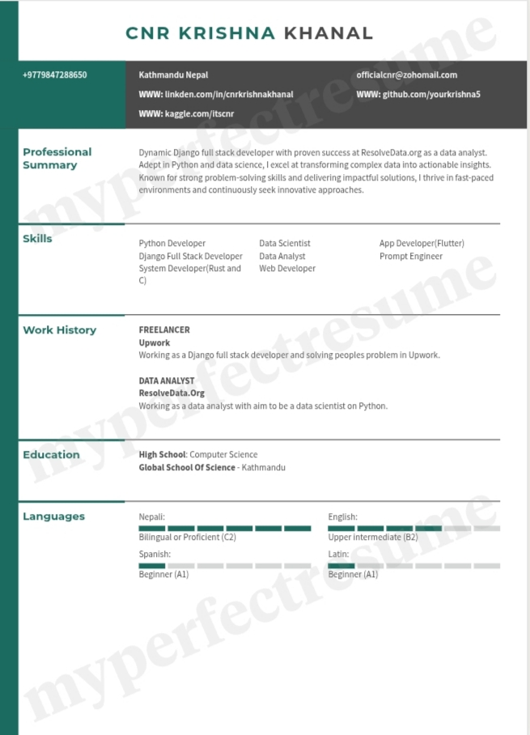

**Project-2:To Prepare a Newspaper Template Using Ms Word**

*Procedure:*

*Step 1: Turn on the computer.*

*Step 2: Click the Start button and open MS Word.*

*Step 3: Open a blank document in MS Word.*

*Step 4: Set the page layout by selecting columns (e.g., two or three columns) from the Layout tab.*

*Step 5: Add a heading or title for your newspaper using bold and large fonts.*

*Step 6: Insert text boxes or shapes to place news articles, headlines, and images creatively.*

*Step 7: Use different fonts, sizes, and colors to design each section attractively.*

*Step 8: Insert pictures or graphics to make the newspaper more appealing.*

*Step 9: Review your content, correct any mistakes, and then save the newspaper in a suitable folder.*

**Output:**



**Project-3:To prepare a Calender using Ms Word**

*Procedure:*

*Step 1: Turn on the computer.*

*Step 2: Click the Start button and open MS Word.*

*Step 3: Open a blank document in MS Word.*

*Step 4: Set the page orientation to Landscape from the Layout tab for better calendar view.*

*Step 5: Insert a table (e.g., 7 columns for days of the week and 5-6 rows for the weeks) using the Insert tab.*

*Step 6: Label the top row with the days (Sunday to Saturday).*

*Step 7: Fill in the calendar dates in each box according to the month.*

*Step 8: Customize the calendar with different colors, fonts, and even add pictures or events.*

*Step 9: Review the calendar and save it in a suitable folder.*

**Output:**

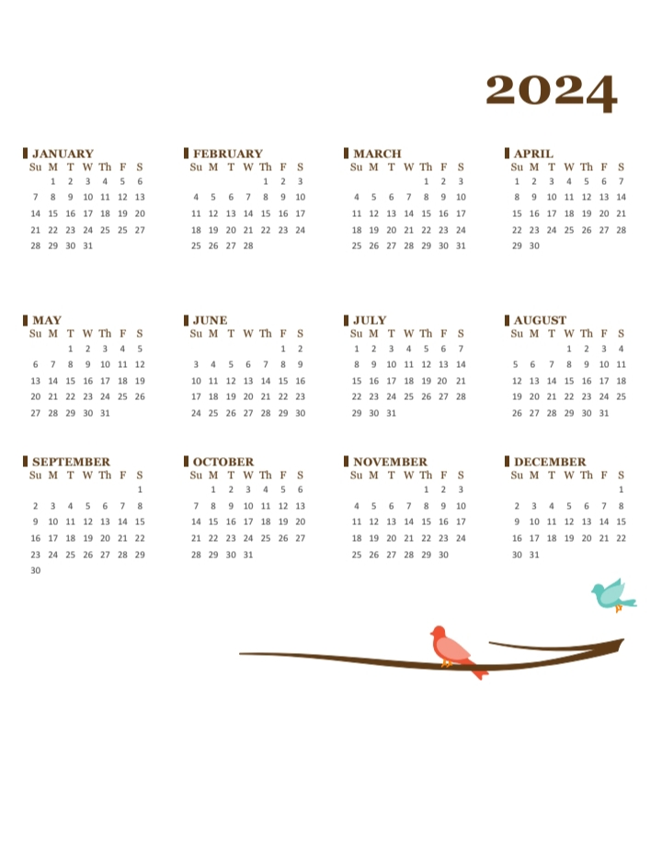

**Project-4:To prepare a Character Certificate using Ms Word**

*Procedure:*

*Step 1: Turn on the computer.*

*Step 2: Click the Start button and open MS Word.*

*Step 3: Open a blank document in MS Word.*

*Step 4: Set the page layout by adjusting the margins and orientation (Portrait is usually better).*

*Step 5: Add a heading at the top such as "Character Certificate" using bold and large fonts.*

*Step 6: Write the main body text, including the name of the student/person, institution, and a brief statement about their character.*

*Step 7: Insert lines for signatures, dates, and official stamps if needed.*

*Step 8: Make the certificate look attractive by using borders, different fonts, and formal styles.*

*Step 9: Review your character certificate, make corrections if needed, and save it in a suitable folder.*

**Output:**

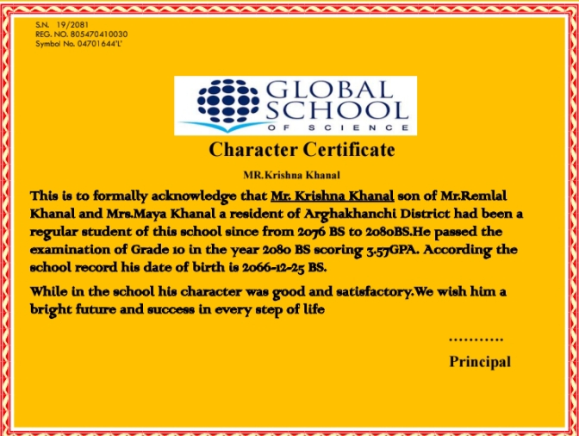

**2*.Ms Excel***

Microsoft Excel (MS Excel) is a powerful spreadsheet software developed by Microsoft. It is used to organize, analyze, and visualize data efficiently. Excel allows users to perform calculations using formulas and functions, create charts and graphs, manage large data sets, and generate reports. It is widely used in various fields such as education, finance, business, and research for data entry, budgeting, accounting, and analysis. With its grid layout and built-in tools, MS Excel simplifies complex tasks and enhances productivity for both personal and professional use

Applications of MS Excel

1. Recording and analyzing data using spreadsheets.

2. Creating charts and graphs for data visualization.

3. Using formulas and functions for quick calculations.

4. Managing budgets, expenses, and financial records.

5. Tracking attendance, inventory, or sales reports.

6. Automating tasks using macros and conditional formatting.

**Steps to open Ms Excel**

1. Turn on your device (computer or mobile).

2. Click on the Start menu (Windows) or find the app icon.

3. Search for “Microsoft Excel” in the search bar.

4. Click on the Microsoft Excel icon when it appears.

5. Wait for the app to open, then start a new or existing document.

**Project-1:To Prepare Students Grade Sheet in Ms Excel**

*Procedure:*

*Step 1: Turn on the computer.*

*Step 2: Click the Start button and open MS Excel.*

*Step 3: Open a blank workbook in MS Excel.*

*Step 4: Type a suitable heading like “Student Gradesheet” at the top of the sheet.*

*Step 5: Enter column headers such as Roll No, Name, Subject 1, Subject 2, Subject 3, etc.*

*Step 6: Fill in the rows with student details and their marks for each subject.*

*Step 7: Adjust the column widths for better readability and align the text properly.*

*Step 8: Use bold fonts, borders, and shading to format the table neatly.*

*Step 9: Review the gradesheet and save it in a suitable folder.*

***Formulas***

Total Marks: =SUM(C5:E5)[Then drag down to last row]

Percentage: =(F5/300)*100

Grade: =IF(H5>=90,"A+",IF(H5>=80,"A",IF(H5>=70,"B",IF(H5>=60,"C",IF(H5>=50,"D","F")))))

**Output:**

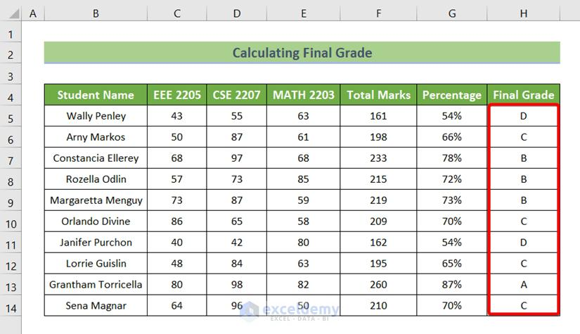

**Project-2:Calculating Electricity Bill in Ms Excel**

*Procedure:*

*Step 1: Turn on the computer.*

*Step 2: Click the Start button and open MS Excel.*

*Step 3: Open a blank workbook in MS Excel.*

*Step 4: Type a suitable heading like “Monthly Electric Bill of [Your Society Name]” at the top of the sheet.*

*Step 5: Enter column headers such as Flat No., Owner’s Name, Current Meter Reading, Past Meter Reading, Consumed Unit, Unit Price, Total Bill.*

*Step 6: Fill in the rows with flat numbers, owners' names, and their meter readings.*

*Step 7: Adjust the column widths for better readability and align the text properly.*

*Step 8: Use bold fonts, borders, and shading to format the table neatly.*

*Step 9: Review the electric bill sheet and save it in a suitable folder.*

***Formulas***

Consumed Unit: =D5-E5[Then drag down to last row]

Total Bill: =(F5*G5)

**Output:**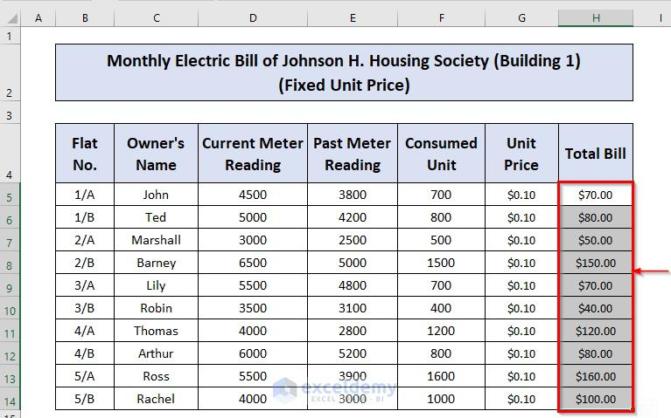

**Project-3:Creating Sales Report using Ms Excel**

*Procedure:*

*Step 1: Turn on the computer.*

*Step 2: Click the Start button and open MS Excel.*

*Step 3: Open a blank workbook in MS Excel.*

*Step 4: Type a suitable heading like “Monthly Sales Report of [Your Company Name]” at the top of the sheet.*

*Step 5: Enter column headers such as Product ID, Product Name, Quantity Sold, Unit Price, Total Sales.*

*Step 6: Fill in the rows with product details, quantity sold, and unit prices.*

*Step 7: Adjust the column widths for better readability and align the text properly.*

*Step 8: Use bold fonts, borders, and shading to format the table neatly.*

*Step 9: Review the sales report and save it in a suitable folder.*

**Formulas**

Amount:=D6*E6

Tax:=F6*5%

Commission:=F6*2%

Total=F6+G6+H6

**Output:**

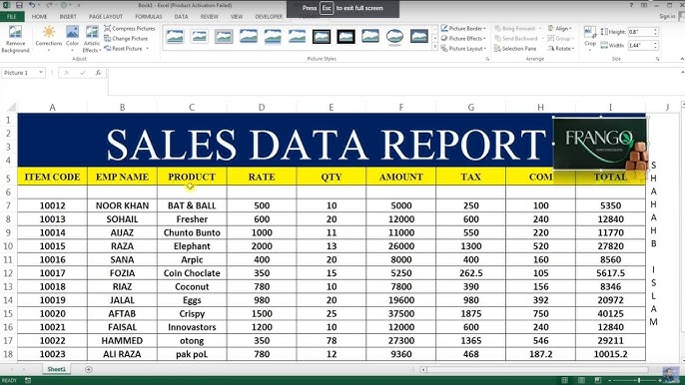

**Project-4:Salary Distribution using Ms Excel**

*Procedure:*

*Step 1: Turn on the computer.*

*Step 2: Click the Start button and open MS Excel.*

*Step 3: Open a blank workbook in MS Excel.*

*Step 4: Type a suitable heading like "Salary Distribution Sheet of [Company Name] [Month/Year]" at the top of the sheet.*

*Step 5: Enter the following column headers:*

*Employee ID, Employee Name, Basic Salary, Allowances, Deductions, Net Salary.*

*Step 6: Fill in the rows with employee details such as ID, name, basic salary, allowances, and deductions.*

*Step 7: Adjust the column widths for better visibility and align the text properly.*

*Step 8: Format the table using bold fonts, borders, and different background colors for the header row.*

*Step 9: Apply formulas to calculate Net Salary.*

*Step 10: Review the salary distribution sheet carefully and save it in an appropriate folder.*

**Formulas:**

Total Gross Salary:=C5+D5+E5+F5+G5+H5+I5

Total Deduction:=K5+L5+M5+N5

**Output:**

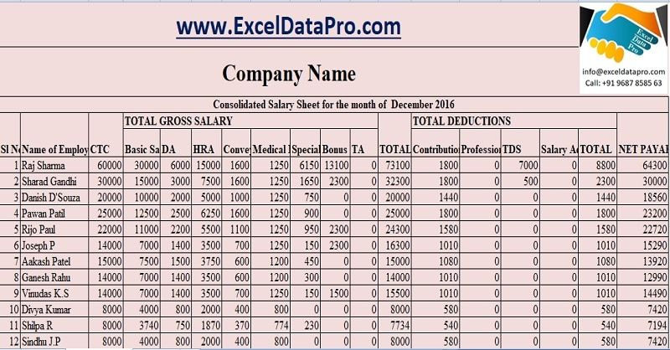

**3*.Ms Powerpoint***

Microsoft PowerPoint is a popular presentation software developed by Microsoft.It is used to create, edit, and display visual presentations that include slides with text, images, animations, and multimedia.MS PowerPoint offers various features like slide transitions, animations, inserting audio/video, and designing attractive layouts.It allows users to present information clearly to an audience in meetings, classrooms, seminars, and more.With its easy-to-use interface and creative tools, MS PowerPoint is widely used in schools, offices, and events around the world.

Applications of MS PowerPoint

1.Creating visual presentations for meetings, lectures, and workshops.

2. Designing slideshows with text, images, charts and multimedia for better understanding.

3. Adding animations and transitions to make presentations engaging and interactive.

4. Creating photo albums, portfolios, and project displays.

5. Recording narrated presentations for online classes and tutorials.

6. Collaborating with team members by sharing and editing presentations in real-time.

**#**

**Steps to open Ms Powerpoint**

1. Turn on your device (computer or mobile).

2. Click on the Start menu (Windows) or find the app icon.

3. Search for “Microsoft Powerpoint" in the search bar.

4. Click on the Microsoft Word icon when it appears.

5. Wait for the app to open, then start a new or existing document.

**Project-1:To prepare a Presentation Using Ms Powerpoint**

*Procedure:*

*Step 1:Turn on the computer.*

*Step 2:Click the Start button and open MS PowerPoint.*

*Step 3:Open a Blank Presentation in MS PowerPoint.*

*Step 4:Click on the Title Slide and type a suitable heading and subtitle.*

*Step 5:Click Home > New Slide to add a new slide.*

*Step 6:Type headings and bullet points on each slide to present your information.*

*Step 7:Insert images, shapes, or charts if needed using the Insert tab.*

*Step 8:Apply a design or theme using the Design tab to make slides attractive.*

*Step 9:Add slide transitions and simple animations if required using the Transitions and Animations tabs.*

*Step 10:Review the presentation and Save the file in a suitable folder.*

**Output:**

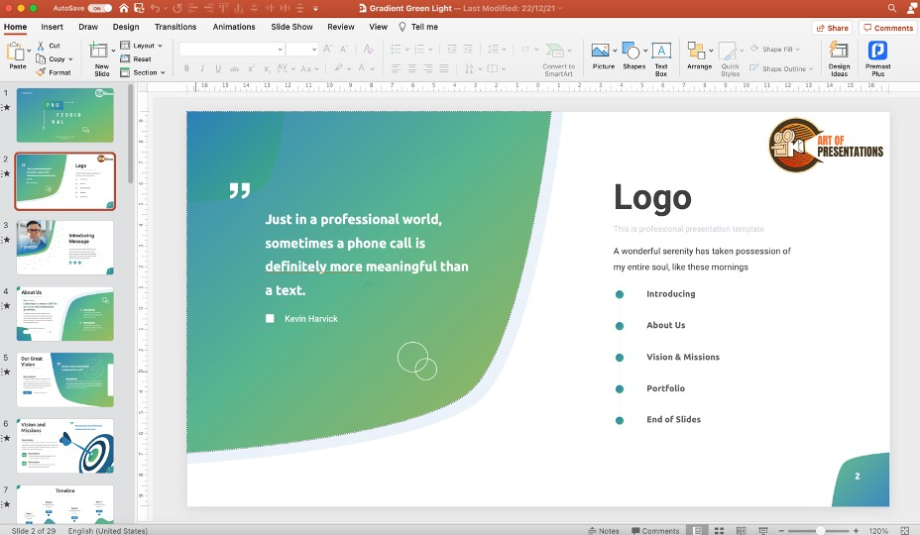

**Project-2:To add an Image to a Presentation**

*Procedure:*

*Step 1:Turn on the computer.*

*Step 2:Click the Start button and open MS PowerPoint.*

*Step 3:Open a Blank Presentation in MS PowerPoint.*

*Step 4:Click on the Title Slide and type a suitable heading and subtitle.*

*Step 5:Click Home > New Slide to add a new slide where you want to insert the image.*

*Step 6:Go to the Insert tab in the menu bar.*

*Step 7:Click on Pictures and choose This Device to select an image from your computer.*

*Step 8:Browse and select the image you want to insert, then click Insert.*

*Step 9:Resize and move the image on the slide as needed.*

*Step 10:Apply picture styles, effects, or borders using the Picture Format tab.*

*Step 11:Review the slide and Save the presentation in a suitable folder.*

**Output:**

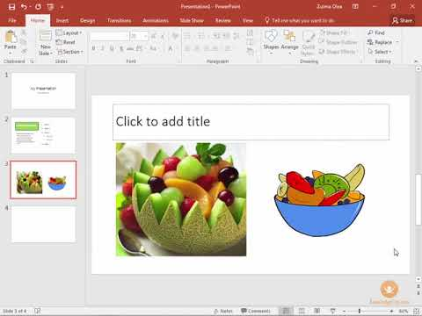

**3.*HTML and CSS***

HTML (HyperText Markup Language) and CSS (Cascading Style Sheets) are the fundamental building blocks of web development. HTML is used to create and structure content on the web, such as headings, paragraphs, images, and links. CSS is used to style and design these web pages by controlling the layout, colors, fonts, and spacing. Together, HTML and CSS allow developers to create attractive, organized, and responsive websites. With their simple syntax and wide support, they are essential tools for building modern web pages, applications, and online content.

Applications of HTML and CSS

1. Creating and structuring web pages with headings, text, images, and links.

2. Designing the visual appearance of websites using colors, fonts, layouts, and spacing.

3. Building responsive websites that adapt to different screen sizes like mobiles, tablets, and desktops.

4. Developing user-friendly forms for collecting information such as surveys and registrations.

5. Creating online portfolios, blogs, news sites, and e-commerce platforms.

6. Improving accessibility and SEO (Search Engine Optimization) of websites for a better user experience and visibility.

Steps to open HTML:

i. Open your Computer.

ii. Click on windows tab and search for Notepad++ or Notepad.

iii. Alternatively, press Windows + R.

iv. After run command appears, type Notepad++ or Notepad.

v. Your Blank page will be open

**Project-1:Heading Tag**

Code:

*<html>*

*<body>*

*<h1>This is the Main Heading</h1>*

*<h2>This is a Subheading</h2>*

*<h3>This is a Smaller Subheading</h3>*

*<h4>This is a Sub-Subheading</h4>*

*<h5>This is a Minor Subheading</h5>*

*<h6>This is the Smallest Heading</h6>*

*</body>*

*</html>*

**Output:**

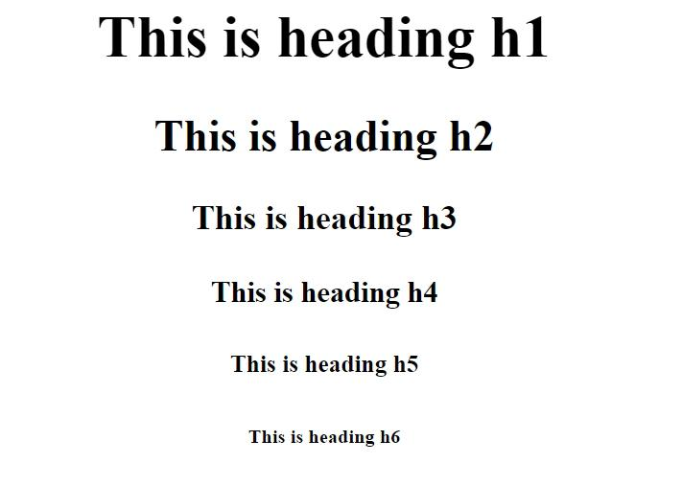

**Project-2:Text Formatting**

Code:

*<!DOCTYPE html>*

*<html lang="en">*

*<head>*

*<meta charset="UTF-8">*

*<title>Text Formatting Example</title>*

*</head>*

*<body>*

*<p>*

*<strong>Strong:</strong>*

*This text is important and bold.*

*</p>*

*<p>*

*<em>Emphasized:</em>*

*This text is emphasized and italic.*

*</p>*

*<p>*

*<b>Bold:</b>*

*This text is bold.*

*</p>*

*<p>*

*<i>Italic:</i>*

*This text is italic.* **Output:**

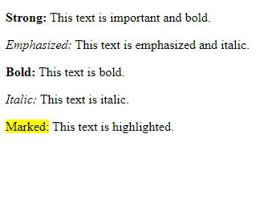 *</p>*

*<p>*

*<mark>Marked:</mark>*

*This text is highlighted.*

*</p>*

*</body>*

*</html>*

**Project-3:Font Tag**

Code:

*<!DOCTYPE html>*

*<html lang="en">*

*<head>*

*<meta charset="UTF-8">*

*<meta http-equiv="X-UA-Compatible" content="IE=edge">*

*<meta name="viewport" content="width=device-width, initial-scale=1.0">*

*<title>font tag in html</title>*

*</head>*

*<body>*

*<font size="1">Welcome to the platform!</font>*

*<p>Text written without using the font tag in html!</p>*

*</body>*

*</html>*

**Output:**

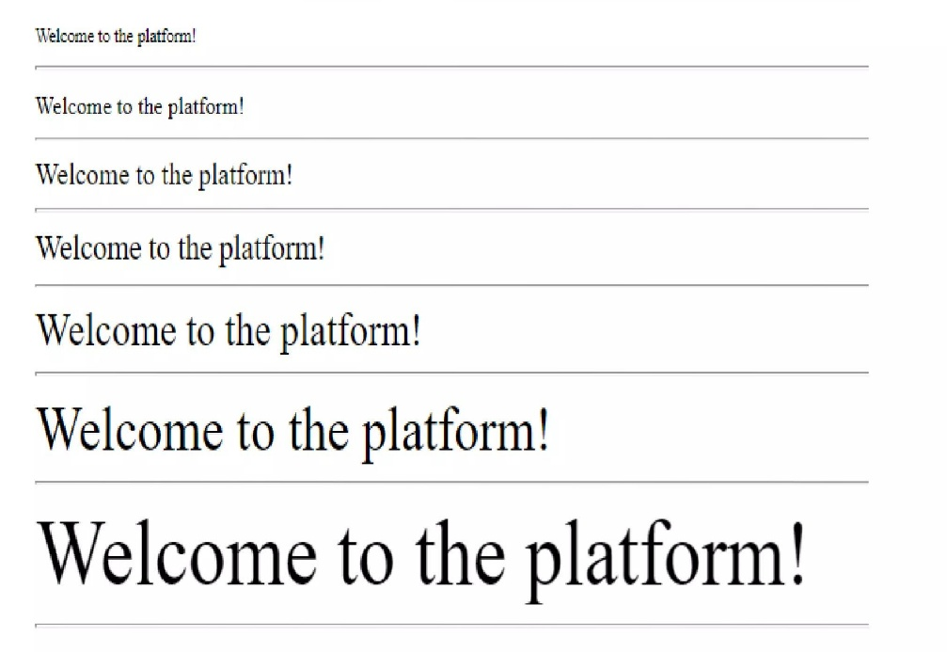

**...**

**Project-4:Inserting image in HTML**

Code:

<!DOCTYPE html>

<html>

<head>

<style>

.image-container {

background-image: url(

"https://media.geeksforgeeks.org/wp-content/uploads/20241008160104258350/gfg-demo.png");

width: 80%;

height: 250px;

background-repeat: no-repeat;

}

</style>

</head>

<body>

<h2>

Inserting Image using background-image Property

</h2>

<div class="image-container"></div>

</body> **Output:**

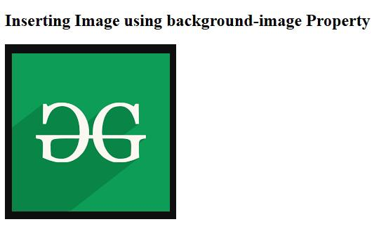

</html>

**Project-5:Inserting Video in HTML File**

Code:

*<!DOCTYPE html>*

*<html lang="en">*

*<head>*

*<meta charset="UTF-8">*

*<meta name="viewport" content="width=device-width, initial-scale=1.0">*

*<title>Video Example</title>*

*</head>*

*<body>*

*<h1>My Below is a Simple Video Example</h1>*

*<video width="640" height="360" controls>*

*<source src="video.mp4" type="video/mp4">*

*Your browser does not support the video tag.*

*</video>*

*</body>*

*</html>*

**Output:**

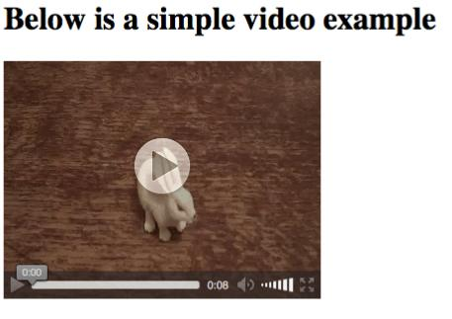

**Project-6:Using hyperlink in HTML**

Code:

* Page-1.html

<!DOCTYPE html>

<html lang="en">

<head>

<meta charset="UTF-8">

<meta name="viewport" content="width=device-width, initial-scale=1.0">

<title>Page 1</title>

</head>

<body>

<h1>This is Page 1</h1>

<p><a href="page2.html">Go to Page 2</a></p>

</body>

</html>

* page-2.html

<!DOCTYPE html>

<html lang="en">

<head>

<meta charset="UTF-8">

<meta name="viewport" content="width=device-width, initial-scale=1.0">

<title>Page 2</title>

</head>

<body>

<h1>This is Page 2</h1>

<p><a href="page1.html">Back to Page 1</a></p>

</body>

</html>

**Output:**

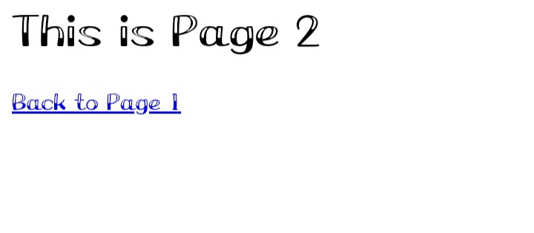

**Project-7:Inserting Table**

Code:

*<!DOCTYPE html>*

*<html>*

*<head>*

*<style>*

*table,*

*th,*

*td {*

*border: 1px solid black;*

*}*

*</style>*

*</head>*

*<body>*

*<table style="width:100%">*

*<tr>*

*<th>Firstname</th>*

*<th>Lastname</th>*

*<th>Age</th>*

*</tr>*

*<tr>*

*<td>Priya</td>*

*<td>Sharma</td>*

*<td>24</td>*

*</tr>*

*<tr>*

*<td>Arun</td>* **Output:**

*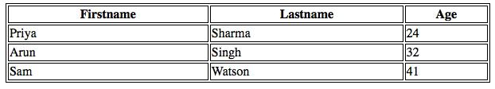 <td>Singh</td>*

*<td>32</td>*

*</tr>*

*<tr>*

*<td>Sam</td>*

*<td>Watson</td>*

*<td>41</td>*

*</tr>*

*</table>*

*</body>*

*</html>*

**Project-8:List Tag**

Code:

<!DOCTYPE html>

<html>

<body>

<h2>Welcome To GSS</h2>

<h5>List of available courses</h5>

<ul>

<li>Data Structures & Algorithm</li>

<li>Web Technology</li>

<li>Aptitude & Logical Reasoning</li>

<li>Programming Languages</li>

</ul>

<h5>Data Structures topics</h5>

<ol>

<li>Array</li>

<li>Linked List</li>

<li>Stacks</li>

<li>Queues</li>

<li>Trees</li>

<li>Graphs</li>

</ol>

</body>

</html>

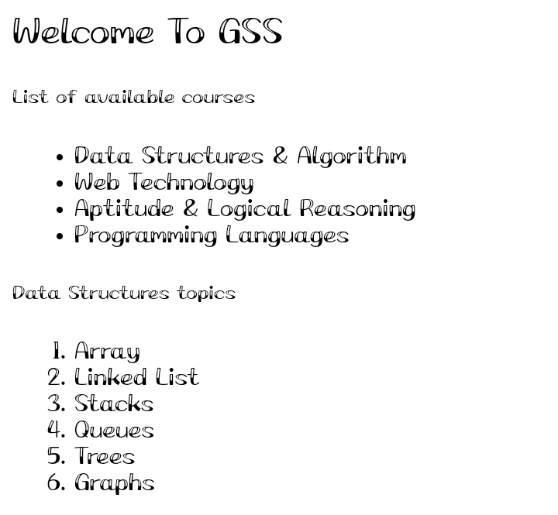**Output:**

**Project-9:Form Tag**

Code:

*<!DOCTYPE html>*

*<html lang="en">*

*<head>*

*<meta charset="UTF-8">*

*<meta name="viewport" content="width=device-width, initial-scale=1.0">*

*<title>Simple Form</title>*

*</head>*

*<body>*

*<h1>Contact Form</h1>*

*<form action="submit.php" method="post">*

*<label for="name">Name:</label><br>*

*<input type="text" id="name" name="name"><br><br>*

*<label for="email">Email:</label><br>*

*<input type="email" id="email" name="email"><br><br>*

*<label for="message">Message:</label><br>*

*<textarea id="message" name="message" rows="5" cols="30"></textarea><br><br>*

*<input type="submit" value="Submit">*

*</form>*

*</body>*

*</html>*

**Output:**

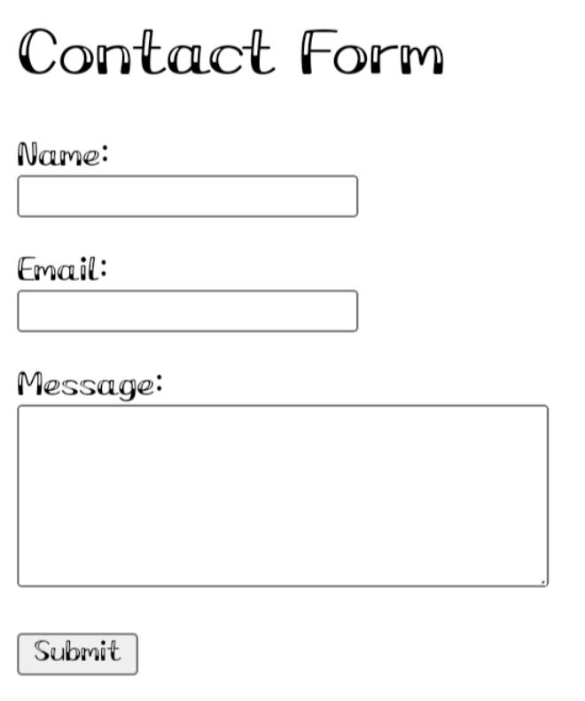

**Project-9:Css**

**a)Inline Css**

Code:

*<!DOCTYPE html>*

*<html lang="en">*

*<head>*

*<meta charset="UTF-8">*

*<meta name="viewport" content="width=device-width, initial-scale=1.0">*

*<title>Inline CSS Example</title>*

*</head>*

*<body>*

*<h1 style="color: blue; text-align: center;">Hello, World!</h1>*

*<p style="font-size: 18px; color: green;">This is a paragraph with inline CSS.</p>*

*</body>*

*</html>*

**Output:**

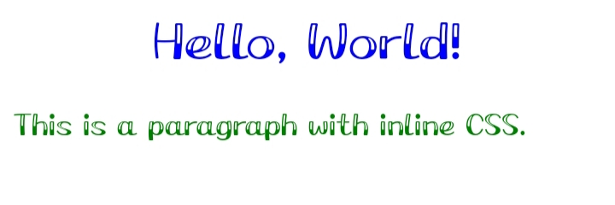

**b)Internal Css**

Code:

*<!DOCTYPE html>*

*<html lang="en">*

*<head>*

*<meta charset="UTF-8">*

*<meta name="viewport" content="width=device-width, initial-scale=1.0">*

*<title>Internal CSS Example</title>*

*<style>*

*body {*

*background-color: lightyellow;*

*}*

*h1 {*

*color: blue;*

*text-align: center;*

*}*

*p {*

*font-size: 18px;*

*color: green;*

*}*

*</style>*

*</head>*

*<body>*

*<h1>Hello, World!</h1>*

*<p>This is a paragraph styled with internal CSS.</p>*

*</body>*

*</html>*

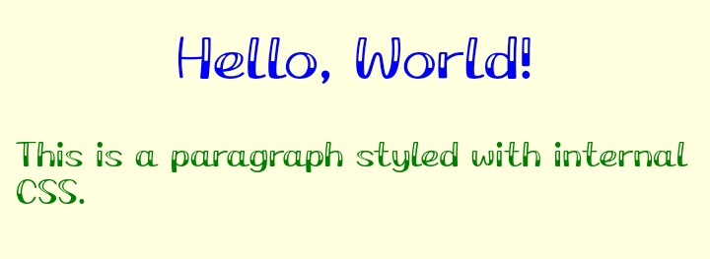**Output:**

**c)External Css**

***Index.html***

*<!DOCTYPE html>*

*<html lang="en">*

*<head>*

*<meta charset="UTF-8">*

*<meta name="viewport" content="width=device-width, initial-scale=1.0">*

*<title>External CSS Example</title>*

*<link rel="stylesheet" href="style.css">*

*</head>*

*<body>*

*<h1>Hello, World!</h1>*

*<p>This paragraph is styled using external CSS.</p>*

*</body>*

*</html>*

***Style.css***

*body {*

*background-color: lightblue;*

*}*

*h1 {*

*color: navy;*

*text-align: center;*

*}*

*p {*

*color: darkgreen;*

*font-size: 18px;*

*}*

**Output:**

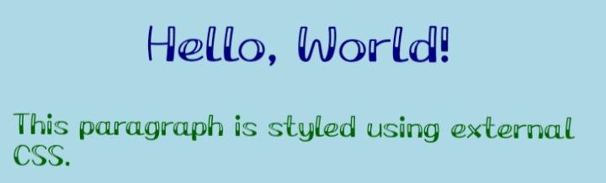

**4*.C Programming***

**C is a procedural programming

language. It was initially developed by

Dennis Ritchie in the year 1972. It was

mainly developed as a system

programming language to write an

operating system. The main features of

the C language include low-level

memory access, a simple set of

keywords, and a clean style, these features make C language suitable for

system programmings like an operating system or compiler development.

Many later languages have borrowed syntax/features directly or indirectly

from the C language. Like syntax of Java, PHP, JavaScript, and many other

languages are mainly based on the C language. C is a procedural

programming language. It was initially developed by Dennis Ritchie in the

year 1972. It was mainly developed as a system programming language to

write an operating system. The main features of the C language include lowlevel memory access, a simple set of keywords, and a clean style, these

features make C language suitable for system programming's like an

operating system or compiler development.

Many later languages have borrowed syntax/features directly or indirectly

from the C language. Like syntax of Java, PHP, JavaScript, and many other

languages are mainly based on the C language.

**Simple Programs**

**Q.N.1**

**// Write a program to print "Hello, World!".**

**#include <stdio.h>**

**int main() {**

**printf("Hello, World!\n");**

**printf("Programmer - Krishna Khanal");**

**return 0;**

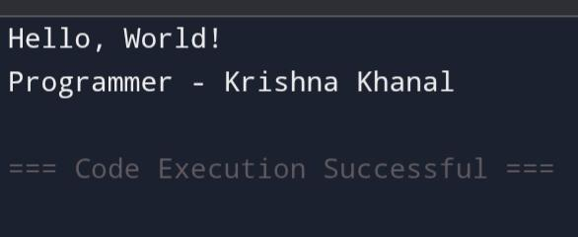**}**

**Q.N.2**

**// Write a program to print your name.**

**#include <stdio.h>**

**int main() {**

**printf("Krishna Khanal\n");**

**printf("Programmer - Krishna Khanal");**

**return 0;**

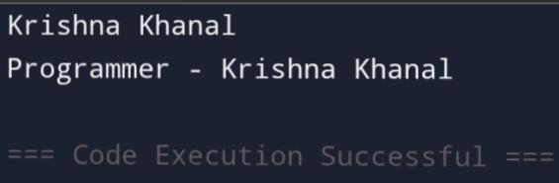**}**

**Q.N.3**

**// Write a program to add two numbers and display the result.**

**#include <stdio.h>**

**int main() {**

**int a = 5, b = 7;**

**int sum = a + b;**

**printf("%d\n", sum);**

**printf("Programmer - Krishna Khanal");**

**return 0;**

**}**

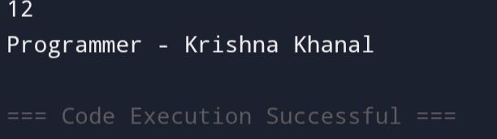

**Q.N.4**

**// Write a program to subtract two numbers and display the result.**

**#include <stdio.h>**

**int main() {**

**int a = 10, b = 3;**

**int result = a - b;**

**printf("%d\n", result);**

**printf("Programmer - Krishna Khanal");**

**return 0;**

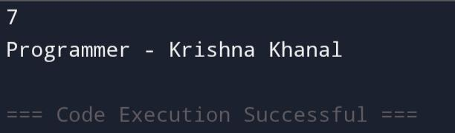**}**

**Q.N.5**

**// Write a program to multiply two numbers and display the result.**

**#include <stdio.h>**

**int main() {**

**int a = 4, b = 6;**

**int product = a * b;**

**printf("%d\n", product);**

**printf("Programmer - Krishna Khanal");**

**return 0;**

**}**

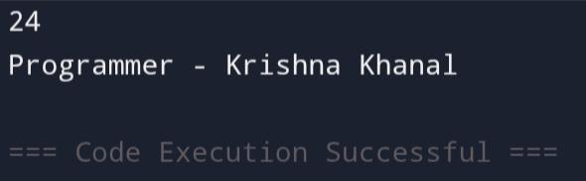

**Q.N.6**

**// Write a program to declare a variable and print its value.**

**#include <stdio.h>**

**int main() {**

**int num = 25;**

**printf("%d\n", num);**

**printf("Programmer - Krishna Khanal");**

**return 0;**

**}**

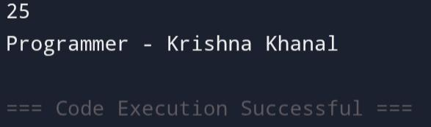

**...**

**Q.N.7**

**// Write a program to print the sum of three numbers.**

**#include <stdio.h>**

**int main() {**

**int a = 2, b = 4, c = 6;**

**int sum = a + b + c;**

**printf("%d\n", sum);**

**printf("Programmer - Krishna Khanal");**

**return 0;**

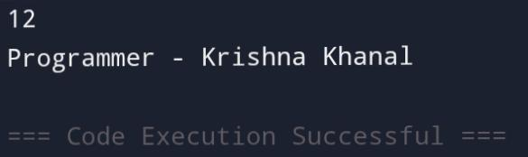**}**

**I/O Function in C**

**Q.N.1**

**// Write a program to take an integer input from the user and print it.**

**#include <stdio.h>**

**int main() {**

**int num;**

**printf("Enter an integer: ");**

**scanf("%d", &num);**

**printf("You entered: %d\n", num);**

**printf("Programmer - Krishna Khanal");**

**return 0;**

**}**

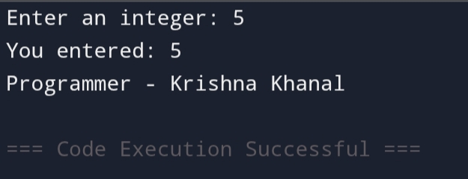

**Q.N.2**

**// Write a program to take two integers from the user and print their sum.**

**#include <stdio.h>**

**int main() {**

**int a, b;**

**printf("Enter first number: ");**

**scanf("%d", &a);**

**printf("Enter second number: ");**

**scanf("%d", &b);**

**printf("Sum is: %d\n", a + b);**

**printf("Programmer - Krishna Khanal");**

**return 0;**

**}**

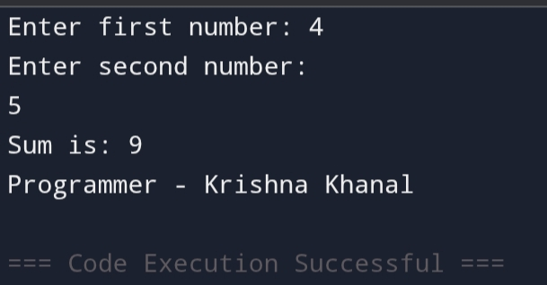

**Q.N.3**

**// Write a program to take a character input from the user and print it.**

**#include <stdio.h>**

**int main() {**

**char ch;**

**printf("Enter a character: ");**

**scanf(" %c", &ch);**

**printf("You entered: %c\n", ch);**

**printf("Programmer - Krishna Khanal");**

**return 0;**

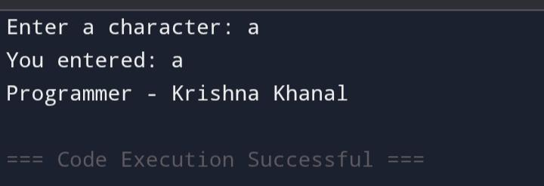

**If Statement**

**Q.N.1**

**// Write a program to check if a number is positive and print a message.**

**#include <stdio.h>**

**int main() {**

**int num;**

**printf("Enter a number: ");**

**scanf("%d", &num);**

**if (num > 0) {**

**printf("The number is positive.\n");**

**}**

**printf("Programmer - Krishna Khanal");**

**return 0;**

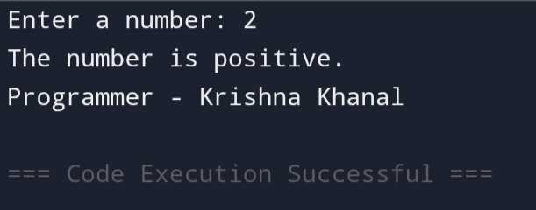**}**

**If..Else statement**

**Q.N.1**

**// Write a program to check if a number is positive or negative.**

**#include <stdio.h>**

**int main() {**

**int num;**

**printf("Enter a number: ");**

**scanf("%d", &num);**

**if (num >= 0) {**

**printf("The number is positive.\n");**

**} else {**

**printf("The number is negative.\n");**

**}**

**printf("Programmer - Krishna Khanal");**

**return 0;**

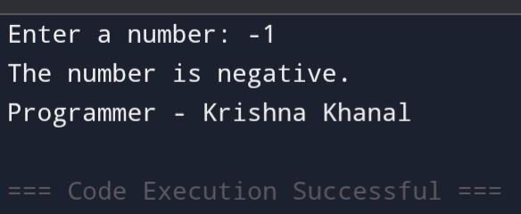**}**

**Q.N.2**

**// Write a program to check if a number is even or odd.**

**#include <stdio.h>**

**int main() {**

**int num;**

**printf("Enter a number: ");**

**scanf("%d", &num);**

**if (num % 2 == 0) {**

**printf("The number is even.\n");**

**} else {**

**printf("The number is odd.\n");**

**}**

**printf("Programmer - Krishna Khanal");**

**return 0;**

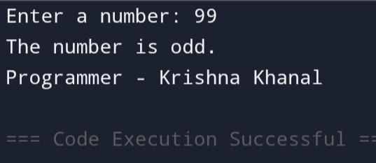**}**

**Q.N.3**

**// Write a program to check if a person is eligible to vote (age >= 18).**

**#include <stdio.h>**

**int main() {**

**int age;**

**printf("Enter your age: ");**

**scanf("%d", &age);**

**if (age >= 18) {**

**printf("You are eligible to vote.\n");**

**} else {**

**printf("You are not eligible to vote.\n");**

**}**

**printf("Programmer - Krishna Khanal");**

**return 0;**

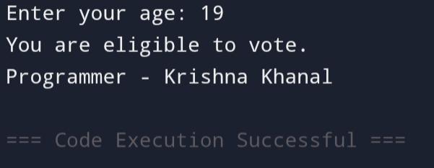**}**

**...**

**If...Else...If Ladder**

**Q.n.1**

**// Write a program to check if a number is positive, negative, or zero.**

**#include <stdio.h>**

**int main() {**

**int num;**

**printf("Enter a number: ");**

**scanf("%d", &num);**

**if (num > 0) {**

**printf("Positive number.\n");**

**} else if (num < 0) {**

**printf("Negative number.\n");**

**} else {**

**printf("Zero.\n");**

**}**

**printf("Programmer - Krishna Khanal");**

**return 0;**

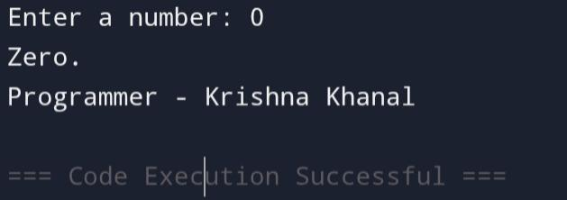**}**

**Q.N.2**

**// Write a program to print grade based on marks (>=90 A, >=75 B, >=50 C, else Fail).**

**#include <stdio.h>**

**int main() {**

**int marks;**

**printf("Enter marks: ");**

**scanf("%d", &marks);**

**if (marks >= 90) {**

**printf("Grade A\n");**

**} else if (marks >= 75) {**

**printf("Grade B\n");**

**} else if (marks >= 50) {**

**printf("Grade C\n");**

**} else {**

**printf("Fail\n");**

**}**

**printf("Programmer - Krishna Khanal");**

**return 0;**

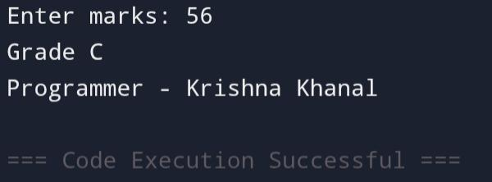**}**

**Q.N.3**

**// Write a program to compare two numbers and print which one is greater or if they are equal.**

**#include <stdio.h>**

**int main() {**

**int a, b;**

**printf("Enter first number: ");**

**scanf("%d", &a);**

**printf("Enter second number: ");**

**scanf("%d", &b);**

**if (a > b) {**

**printf("First number is greater.\n");**

**} else if (b > a) {**

**printf("Second number is greater.\n");**

**} else {**

**printf("Both numbers are equal.\n");**

**}**

**printf("Programmer - Krishna Khanal");**

**return 0;**

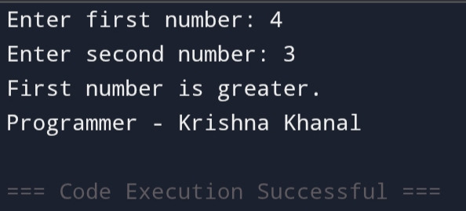**}**

**Nested If/Else Statement**

**// Write a program to check whether a number is prime or not using nested if-else.**

**#include <stdio.h>**

**int main() {**

**int num, i, flag = 0;**

**printf("Enter a number: ");**

**scanf("%d", &num);**

**if (num <= 1) {**

**printf("Not a prime number.\n");**

**} else {**

**i = 2;**

**while (i <= num / 2) {**

**if (num % i == 0) {**

**flag = 1;**

**break;**

**}**

**i++;**

**}**

**if (flag == 0) {**

**printf("Prime number.\n");**

**} else {**

**printf("Not a prime number.\n");**

**}**

**}**

**printf("Programmer - Krishna Khanal");**

**return 0;**

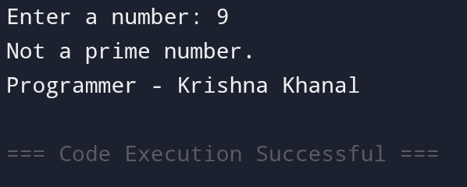**}**

**Switch Case**

**Q.n.1**

**// Write a program to find the largest of three numbers using switch-case.**

**#include <stdio.h>**

**int main() {**

**int a, b, c;**

**printf("Enter three numbers: ");**

**scanf("%d %d %d", &a, &b, &c);**

**switch (1) {**

**case 1:**

**if (a >= b && a >= c) {**

**printf("%d is the largest\n", a);**

**}**

**break;**

**case 2:**

**if (b >= a && b >= c) {**

**printf("%d is the largest\n", b);**

**}**

**break;**

**case 3:**

**if (c >= a && c >= b) {**

**printf("%d is the largest\n", c);**

**}**

**break;**

**}**

**printf("Programmer - Krishna Khanal");**

**return 0;**

**}**

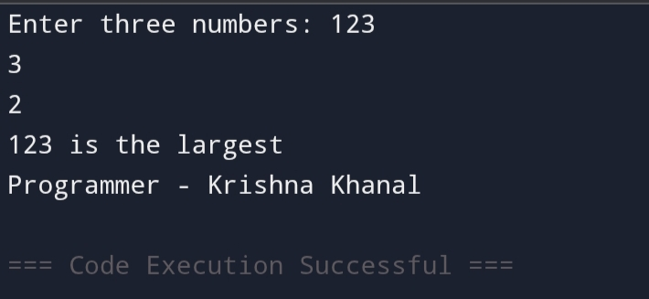

**Q.n.2**

**// Write a program to convert a lowercase letter to uppercase using switch-case.**

**#include <stdio.h>**

**int main() {**

**char ch;**

**printf("Enter a lowercase letter: ");**

**scanf("%c", &ch);**

**switch(ch) {**

**case 'a': case 'b': case 'c': case 'd': case 'e': case 'f': case 'g': case 'h': case 'i': case 'j': case 'k': case 'l': case 'm': case 'n': case 'o': case 'p': case 'q': case 'r': case 's': case 't': case 'u': case 'v': case 'w': case 'x': case 'y': case 'z':**

**printf("Uppercase letter: %c\n", ch - 32);**

**break;**

**default:**

**printf("Invalid input\n");**

**}**

**printf("Programmer - Krishna Khanal");**

**return 0;**

**}**

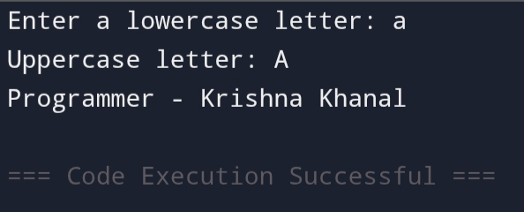

**Q.N.3**

**// Write a program to check if a number is divisible by 3, 5, or both using switch-case.**

**#include <stdio.h>**

**int main() {**

**int num;**

**printf("Enter a number: ");**

**scanf("%d", &num);**

**switch(1) {**

**case 1:**

**if (num % 3 == 0 && num % 5 == 0) {**

**printf("Divisible by both 3 and 5\n");**

**} else if (num % 3 == 0) {**

**printf("Divisible by 3\n");**

**} else if (num % 5 == 0) {**

**printf("Divisible by 5\n");**

**} else {**

**printf("Not divisible by 3 or 5\n");**

**}**

**break;**

**}**

**printf("Programmer - Krishna Khanal");**

**return 0;**

**}**

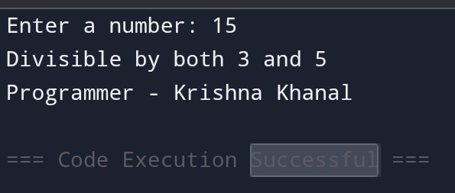

**For LooP**

**Q.n.1**

**// Write a program to print numbers from 1 to 5 using while loop.**

**#include <stdio.h>**

**int main() {**

**int i = 1;**

**while (i <= 5) {**

**printf("%d\n", i);**

**i++;**

**}**

**printf("Programmer - Krishna Khanal");**

**return 0;**

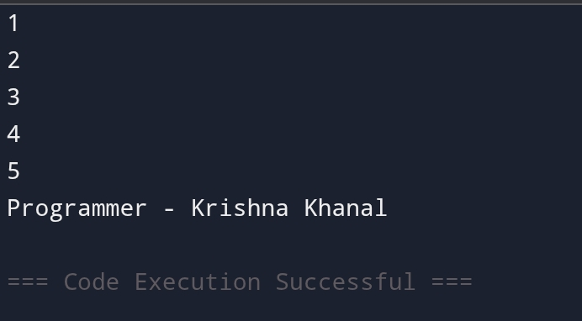**}**

**Q.n.2**

**// Write a program to find the sum of first 10 numbers using while loop.**

**#include <stdio.h>**

**int main() {**

**int sum = 0, i = 1;**

**while (i <= 10) {**

**sum += i;**

**i++;**

**}**

**printf("Sum = %d\n", sum);**

**printf("Programmer - Krishna Khanal");**

**return 0;**

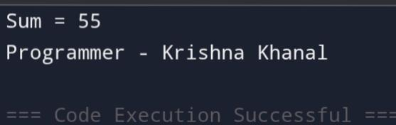**}**

**Q.n.3**

**// Write a program to print the square of numbers from 1 to 5 using while loop.**

**#include <stdio.h>**

**int main() {**

**int i = 1;**

**while (i <= 5) {**

**printf("Square of %d = %d\n", i, i * i);**

**i++;**

**}**

**printf("Programmer - Krishna Khanal");**

**return 0;**

**}**

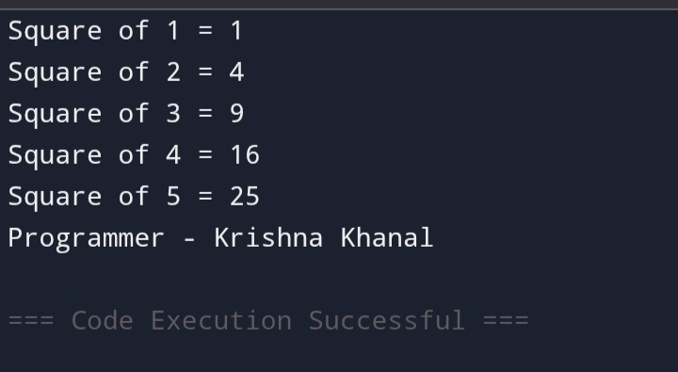

**While Loop**

**Q.n1**

**// Write a program to calculate the factorial of a number using while loop.**

**#include <stdio.h>**

**int main() {**

**int num, factorial = 1;**

**printf("Enter a number: ");**

**scanf("%d", &num);**

**while (num > 1) {**

**factorial *= num;**

**num--;**

**}**

**printf("Factorial = %d\n", factorial);**

**printf("Programmer - Krishna Khanal");**

**return 0;**

**}**

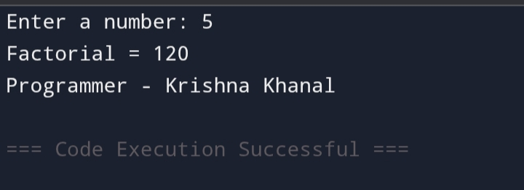

**Q.n.2**

**// Write a program to print numbers in reverse from 5 to 1 using while loop.**

**#include <stdio.h>**

**int main() {**

**int i = 5;**

**while (i >= 1) {**

**printf("%d\n", i);**

**i--;**

**}**

**printf("Programmer - Krishna Khanal");**

**return 0;**

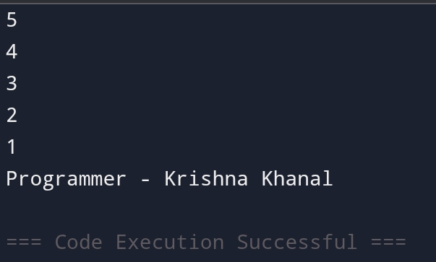**}**

**Q.n.3**

**// Write a program to print first 5 multiples of 3 using while loop.**

**#include <stdio.h>**

**int main() {**

**int i = 1;**

**while (i <= 5) {**

**printf("%d\n", 3 * i);**

**i++;**

**}**

**printf("Programmer - Krishna Khanal");**

**return 0;**

**}**

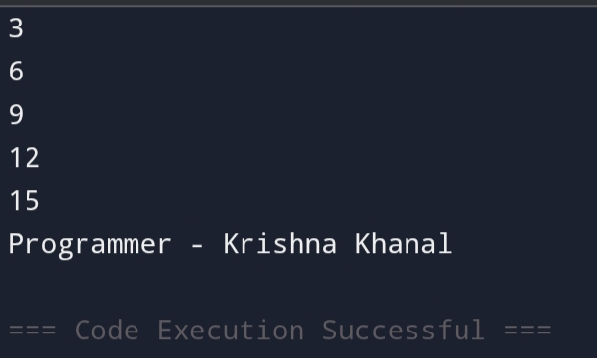

**Do..While Loop**

**Q.n.1**

**// Write a program to ask the user if they want to continue, using a do-while loop.**

**#include <stdio.h>**

**int main() {**

**char choice;**

**do {**

**printf("Do you want to continue (y/n)? ");**

**scanf(" %c", &choice); // Space before %c to handle any extra newline character.**

**} while (choice == 'y' || choice == 'Y');**

**printf("Goodbye!\n");**

**printf("Programmer - Krishna Khanal");**

**return 0;**

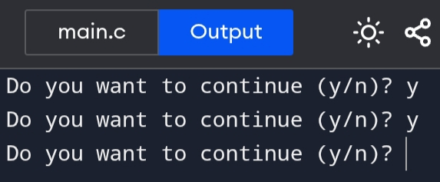**}**

**Q.n.2**

**// Write a program to print a countdown starting from a number, using a do-while loop.**

**#include <stdio.h>**

**int main() {**

**int num;**

**printf("Enter a number to start the countdown: ");**

**scanf("%d", &num);**

**do {**

**printf("%d\n", num);**

**num--;**

**} while (num > 0);**

**printf("Liftoff!\n");**

**printf("Programmer - Krishna Khanal");**

**return 0;**

**}**

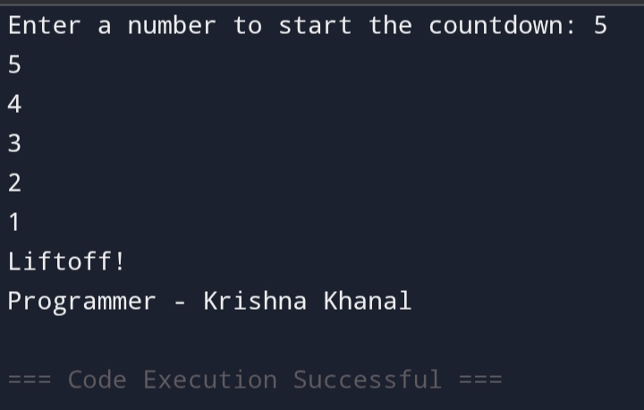

**Break Statemen/Continue Statement/Goto Statement**

**Q.n1**

**// Write a program that exits the loop when the user enters a negative number using break.**

**#include <stdio.h>**

**int main() {**

**int num;**

**while (1) {**

**printf("Enter a number (enter negative number to stop): ");**

**scanf("%d", &num);**

**if (num < 0) {**

**break; // Exit the loop if the number is negative.**

**}**

**printf("You entered: %d\n", num);**

**}**

**printf("Loop ended.\n");**

**printf("Programmer - Krishna Khanal");**

**return 0;**

**}**

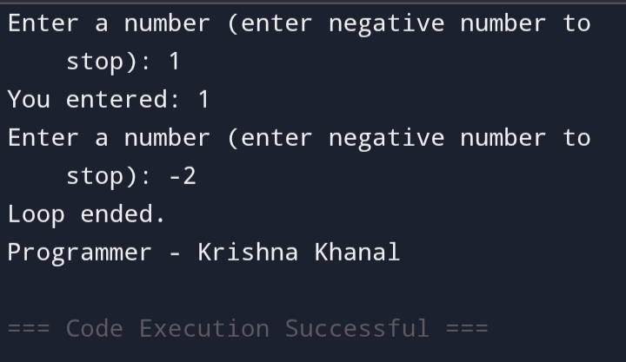

**Q.n.2**

**// Write a program that skips printing even numbers and only prints odd numbers using continue.**

**#include <stdio.h>**

**int main() {**

**for (int i = 1; i <= 10; i++) {**

**if (i % 2 == 0) {**

**continue; // Skip the even numbers.**

**}**

**printf("%d\n", i);**

**}**

**printf("Programmer - Krishna Khanal");**

**return 0;**

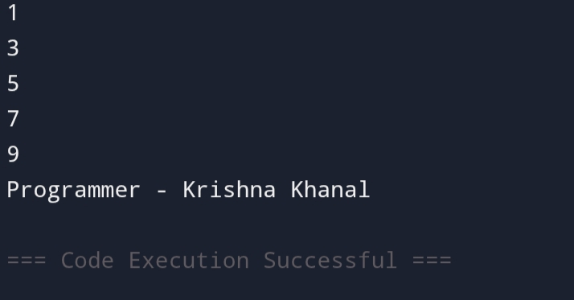**}**

**Q.n.3**

**// Write a program that uses goto to jump to a specific label in the program.**

**#include <stdio.h>**

**int main() {**

**int num;**

**printf("Enter a number: ");**

**scanf("%d", &num);**

**if (num < 0) {**

**goto negative; // Jump to the negative label if the number is negative.**

**}**

**printf("You entered a positive number.\n");**

**goto end; // Jump to the end label.**

**negative:**

**printf("You entered a negative number.\n");**

**end:**

**printf("Program finished.\n");**

**printf("Programmer - Krishna Khanal");**

**return 0;**

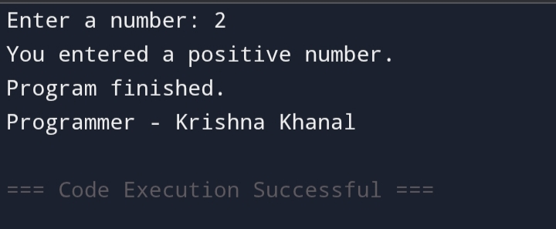**}**

**Array**

**Q.n.1**

**// Write a program to find the largest element in an array.**

**#include <stdio.h>**

**int main() {**

**int arr[] = {10, 20, 5, 30, 25};**

**int largest = arr[0];**

**for (int i = 1; i < 5; i++) {**

**if (arr[i] > largest) {**

**largest = arr[i];**

**}**

**}**

**printf("Largest element = %d\n", largest);**

**printf("Programmer - Krishna Khanal");**

**return 0;**

**}**

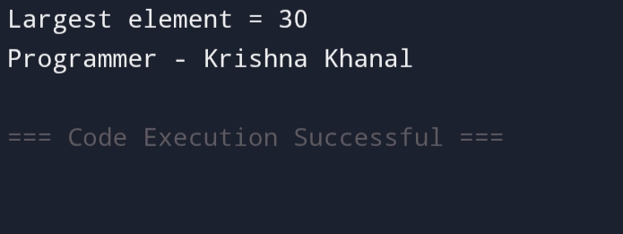

**Q.n.2**

**// Write a program to calculate the sum of elements in an array.**

**#include <stdio.h>**

**int main() {**

**int arr[] = {1, 2, 3, 4, 5};**

**int sum = 0;**

**for (int i = 0; i < 5; i++) {**

**sum += arr[i];**

**}**

**printf("Sum of elements = %d\n", sum);**

**printf("Programmer - Krishna Khanal");**

**return 0;**

**}**

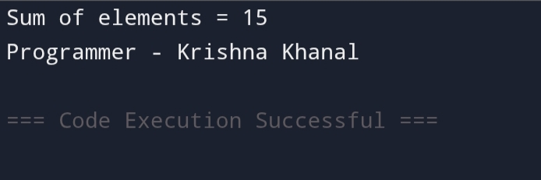

**Q.n.3**

**// Write a program to reverse an array.**

**#include <stdio.h>**

**int main() {**

**int arr[] = {1, 2, 3, 4, 5};**

**int n = 5;**

**printf("Original array: ");**

**for (int i = 0; i < n; i++) {**

**printf("%d ", arr[i]);**

**}**

**printf("\nReversed array: ");**

**for (int i = n - 1; i >= 0; i--) {**

**printf("%d ", arr[i]);**

**}**

**printf("\nProgrammer - Krishna Khanal");**

**return 0;**

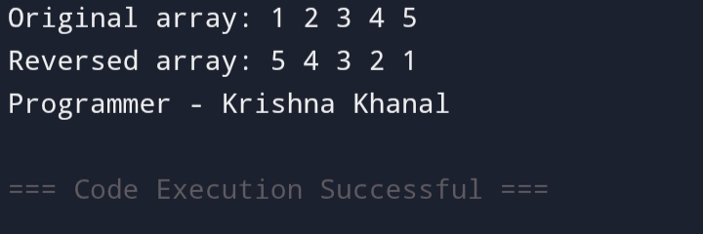**}**

**Q.n.4**

**// Write a program to calculate the sum of all elements in a 2D array.**

**#include <stdio.h>**

**int main() {**

**int arr[2][3] = {{1, 2, 3}, {4, 5, 6}};**

**int sum = 0;**

**for (int i = 0; i < 2; i++) {**

**for (int j = 0; j < 3; j++) {**

**sum += arr[i][j];**

**}**

**}**

**printf("Sum of all elements = %d\n", sum);**

**printf("Programmer - Krishna Khanal");**

**return 0;**

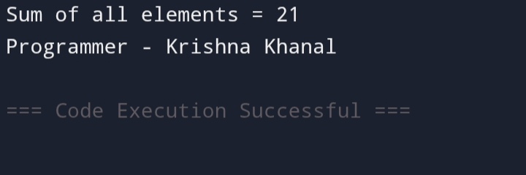**}**

**Q.n.5**

**// Write a program to find the transpose of a 2D array (matrix).**

**#include <stdio.h>**

**int main() {**

**int arr[2][3] = {{1, 2, 3}, {4, 5, 6}};**

**int transpose[3][2];**

**for (int i = 0; i < 2; i++) {**

**for (int j = 0; j < 3; j++) {**

**transpose[j][i] = arr[i][j];**

**}**

**}**

**printf("Transpose of the matrix:\n");**

**for (int i = 0; i < 3; i++) {**

**for (int j = 0; j < 2; j++) {**

**printf("%d ", transpose[i][j]);**

**}**

**printf("\n");**

**}**

**printf("Programmer - Krishna Khanal");**

**return 0;**

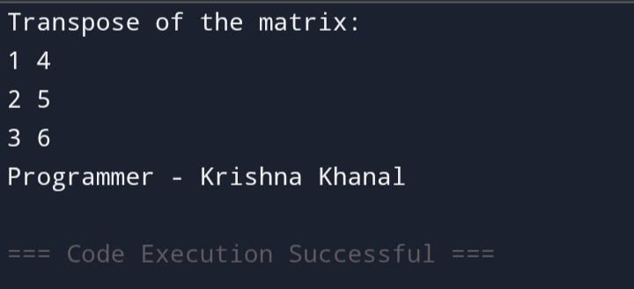**}**

**Q.n.6**

**// Write a program to multiply two matrices (2D arrays).**

**#include <stdio.h>**

**int main() {**

**int A[2][2] = {{1, 2}, {3, 4}};**

**int B[2][2] = {{5, 6}, {7, 8}};**

**int result[2][2];**

**for (int i = 0; i < 2; i++) {**

**for (int j = 0; j < 2; j++) {**

**result[i][j] = 0;**

**for (int k = 0; k < 2; k++) {**

**result[i][j] += A[i][k] * B[k][j];**

**}**

**}**

**}**

**printf("Result of matrix multiplication:\n");**

**for (int i = 0; i < 2; i++) {**

**for (int j = 0; j < 2; j++) {**

**printf("%d ", result[i][j]);**

**}**

**printf("\n");**

**}**

**printf("Programmer - Krishna Khanal");**

**return 0;**

**}**

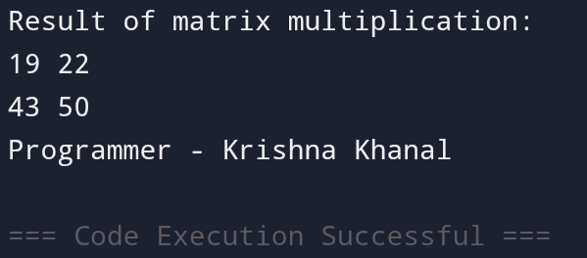

**String Function**

**Q.n.1**

**// Write a program to find the length of a string.**

**#include <stdio.h>**

**#include <string.h>**

**int main() {**

**char str[] = "Hello, World!";**

**printf("Length of the string: %lu\n", strlen(str));**

**printf("Programmer - Krishna Khanal");**

**return 0;**

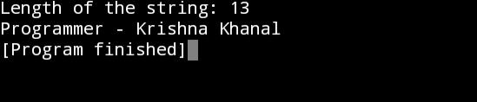**}**

**Q.n.2**

**// Write a program to copy one string to another.**

**#include <stdio.h>**

**#include <string.h>**

**int main() {**

**char source[] = "Hello, Krishna!";**

**char destination[50];**

**strcpy(destination, source);**

**printf("Source: %s\n", source);**

**printf("Destination: %s\n", destination);**

**printf("Programmer - Krishna Khanal");**

**return 0;**

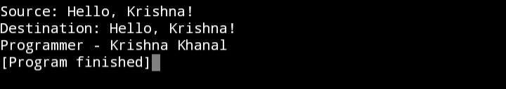**}**

**Q.n.3**

**// Write a program to concatenate two strings.**

**#include <stdio.h>**

**#include <string.h>**

**int main() {**

**char str1[50] = "Hello, ";**

**char str2[] = "World!";**

**strcat(str1, str2);**

**printf("Concatenated string: %s\n", str1);**

**printf("Programmer - Krishna Khanal");**

**return 0;**

**}**

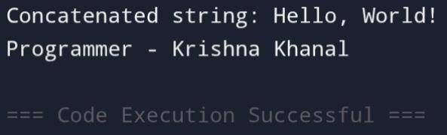

**Q.n.4**

**// Write a program to compare two strings.**

**#include <stdio.h>**

**#include <string.h>**

**int main() {**

**char str1[] = "Apple";**

**char str2[] = "Orange";**

**int result = strcmp(str1, str2);**

**if (result == 0) {**

**printf("Both strings are equal.\n");**

**} else if (result < 0) {**

**printf("First string is less than the second.\n");**

**} else {**

**printf("First string is greater than the second.\n");**

**}**

**printf("Programmer - Krishna Khanal");**

**return 0;**

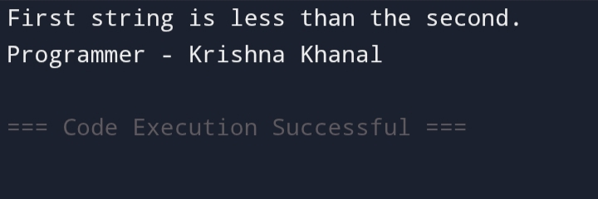**}**

**Q.n.5**

**// Write a program to reverse a string.**

**#include <stdio.h>**

**#include <string.h>**

**int main() {**

**char str[] = "Hello";**

**int length = strlen(str);**

**printf("Reversed string: ");**

**for (int i = length - 1; i >= 0; i--) {**

**printf("%c", str[i]);**

**}**

**printf("\nProgrammer - Krishna Khanal");**

**return 0;**

**}**

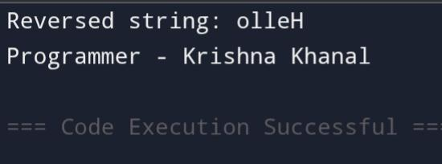

**Q.n.6**

**// Write a program to check if a string is a palindrome.**

**#include <stdio.h>**

**#include <string.h>**

**int main() {**

**char str[] = "madam";**

**int length = strlen(str);**

**int isPalindrome = 1;**

**for (int i = 0; i < length / 2; i++) {**

**if (str[i] != str[length - 1 - i]) {**

**isPalindrome = 0;**

**break;**

**}**

**}**

**if (isPalindrome) {**

**printf("The string is a palindrome.\n");**

**} else {**

**printf("The string is not a palindrome.\n");**

**}**

**printf("Programmer - Krishna Khanal");**

**return 0;**

**}**

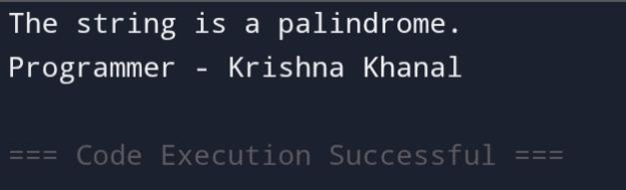

**Q.n.7**

**// Write a program to convert a string to uppercase.**

**#include <stdio.h>**

**#include <ctype.h>**

**#include <string.h>**

**int main() {**

**char str[] = "hello, world!";**

**for (int i = 0; str[i]; i++) {**

**str[i] = toupper(str[i]);**

**}**

**printf("Uppercase string: %s\n", str);**

**printf("Programmer - Krishna Khanal");**

**return 0;**

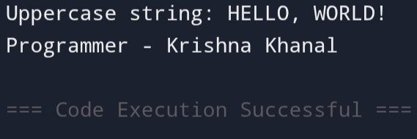**}**

**Conclusion and Summary**

By preparing this project I came to know about different topics like Word processing, MS-Excel, MS-power-point, and Web-page Designing. I learnt the different features of Word, Excel and Web-page designing. Using Word, I learnt to prepare my bio-data, prepare different mathematical symbols and prepare the

certificate and ID card. I also learnt to mail merge. Using Excel, I learnt to prepare mark-sheet, salary-sheet, sales records, and pie chart along withbar graph. I also learnt to prepare the power-point presentation. I also learnt to prepare the webpage. I came to know about the different facilities provided by web-page

designing. I felt very glad while preparing thi**s** report.

**Bibliography**

1. Microsoft Word, Excel, and PowerPoint: Just for Beginners

Author: Dorothy House

Publisher: Outskirts Press

Source: Amazon

2.HTML & CSS: Design and Build Websites

Author: Jon Duckett

Publisher: Wiley

Source: Amazon

3.C Programming Absolute Beginner's Guide

Author: Greg Perry

Publisher: Que Publishing

Source: Amazon